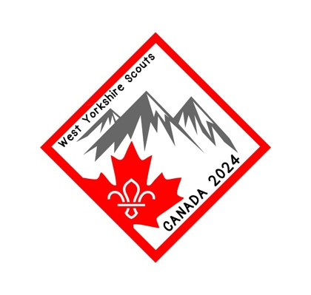
Rocky Adventure Application Form

Please read and complete all sections of this form and return to:
International@wyscouts.org.uk
before 31st December 2021

Please write clearly in capital letters
- APPLICANT DETAILS
Name
Date of Birth |  |  |  |  | Age |  |  | Gender
Address

Post Code |  |  |  | Email
Telephone |  |  |  |  |  | Mobile
- UNIT DETAILS
Please tick which age group applies to you
Scout Troop  (Age 10-14) | Explorer Unit  (Age 14-17) | Network Unit  (Age18-24) | Name of Unit | District
- OTHER INFORMATION
Do you have any special dietary requirements/food allergies / Mobility Requirements ?
 | Vegetarian |  | Vegan |  | Other

Please note this section is confidential and will not affect your application
Please list below any medical conditions that the contingent leaders or selection team should be made aware of e.g. disabilities / allergies / illnesses / asthma etc, and any medication currently being taken such as tablets or inhalers

Please list below anything else you feel the contingent leader should be made aware of, or anything else you would like taken into consideration, please also list here if you feel you would require hardship funds.
- AUTHORISATION Parent/Guardian
Name of Parent/Guardian.

Address (if different from overleaf)

I give permission for (insert name) to apply for the West Yorkshire County Scouts Rocky Adventure Trip.
I give my consent for West Yorkshire County Scouts to use photographs of the contingent for publicity purposes in line with the guidelines, policies and rules of the Scout Association. Should I wish to opt out, I will provide written notification to the leaders in due course.
I understand that payment of a deposit and submission of application form does not guarantee a place.
I enclose a cheque for my deposit of £100 made payable to ‘WYSGlobal’. I understand the deposit is non refundable should this application be successful.
Signed: | Date:

